ReactJS Hands-On Lab
Event Handling in React (eventexamplesapp)

Objective
The goal of this lab was to understand how event handling works in React. I practiced creating event handlers, using the "this" keyword inside class components, invoking a single handler that calls multiple methods, passing arguments to event handler functions, using React's synthetic events, and handling a form submit event to perform a small calculation (currency conversion).

What I Did
- Created a new React app named "eventexamplesapp" using create-react-app inside my ReactJS-HOL project folder.
- Added an Increment button that does two things when clicked: increases the counter value AND shows an alert saying "Hello! Member1" (one click handler invoking two behaviors).
- Added a Decrement button to reduce the counter value.
- Added a "Say welcome" button whose handler function takes an argument ("welcome") and displays it in an alert.
- Added a "Click on me" button that uses React's synthetic event system to show an alert saying "I was clicked".
- Built a small Currency Convertor component with Amount and Currency input fields, and a Submit button.
- Wrote a handleSubmit function that reads the Amount and Currency values from state and calculates the converted value, showing the result in an alert (e.g. "Converting to Euro Amount is 8000" for an amount of 100).
- Adjusted the CSS (App.css / index.css) so the buttons stack vertically and the layout is left-aligned, matching the expected output.
- Ran the app with npm start and tested every button to confirm the alerts and calculations worked correctly.

1. Project Setup
I opened the terminal in VS Code, navigated into the ReactJS-HOL/11. ReactJS-HOL folder, and ran create-react-app to scaffold the new eventexamplesapp project.
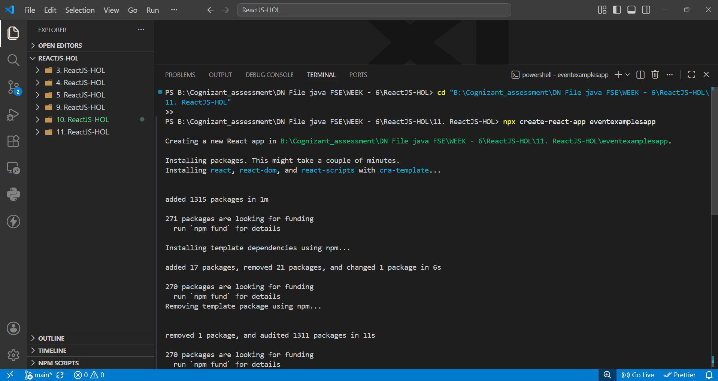
Fig 1: Creating the eventexamplesapp project with create-react-app
Once the packages finished installing, the app was created successfully. I then moved into the eventexamplesapp folder to start working on the files.
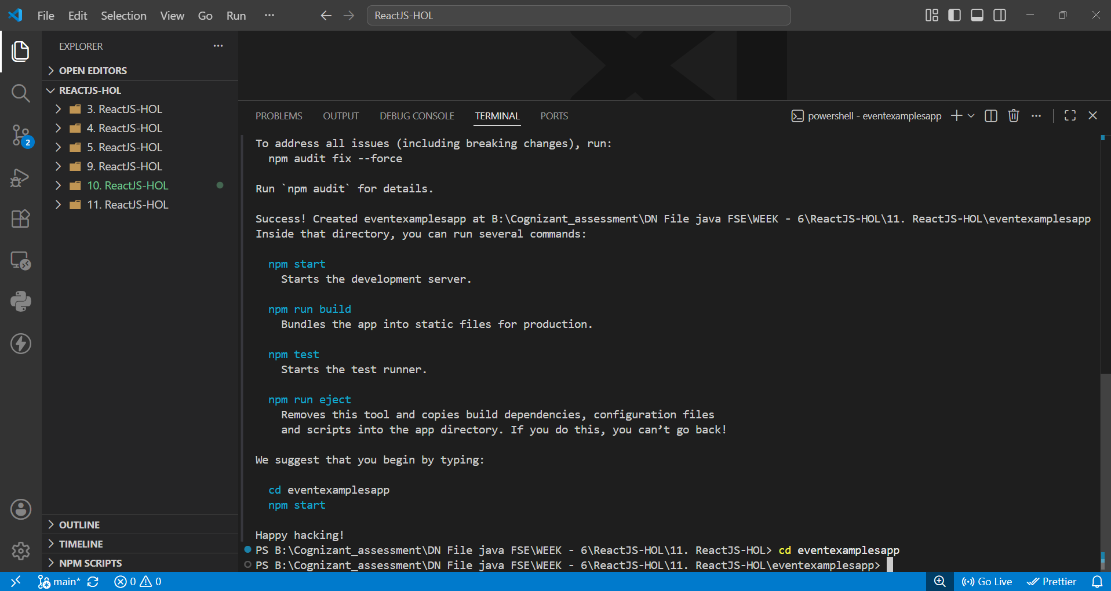
Fig 2: Project created successfully and folder structure ready
After writing the App.js and App.css code, I ran npm start to launch the development server, and it compiled successfully.
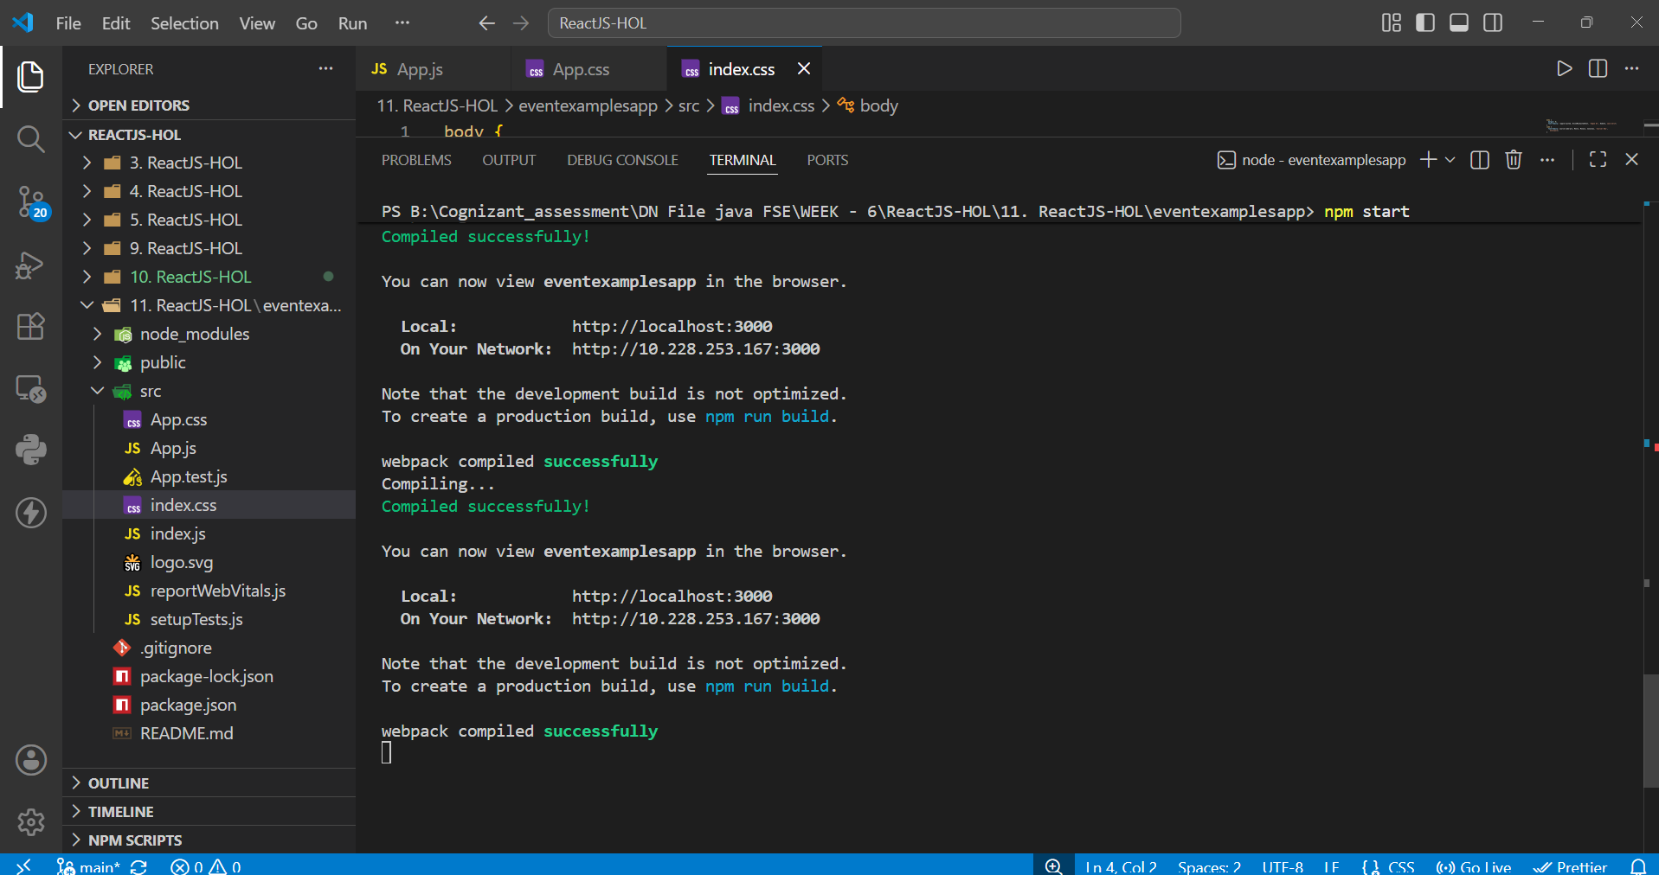
Fig 3: App compiled successfully and running on localhost:3000

2. Increment Button — Two Actions in One Handler
Clicking the Increment button increases the counter (from 0 to 1) and also triggers an alert box showing "Hello! Member1". This confirms that a single onClick handler can invoke multiple pieces of logic at once.
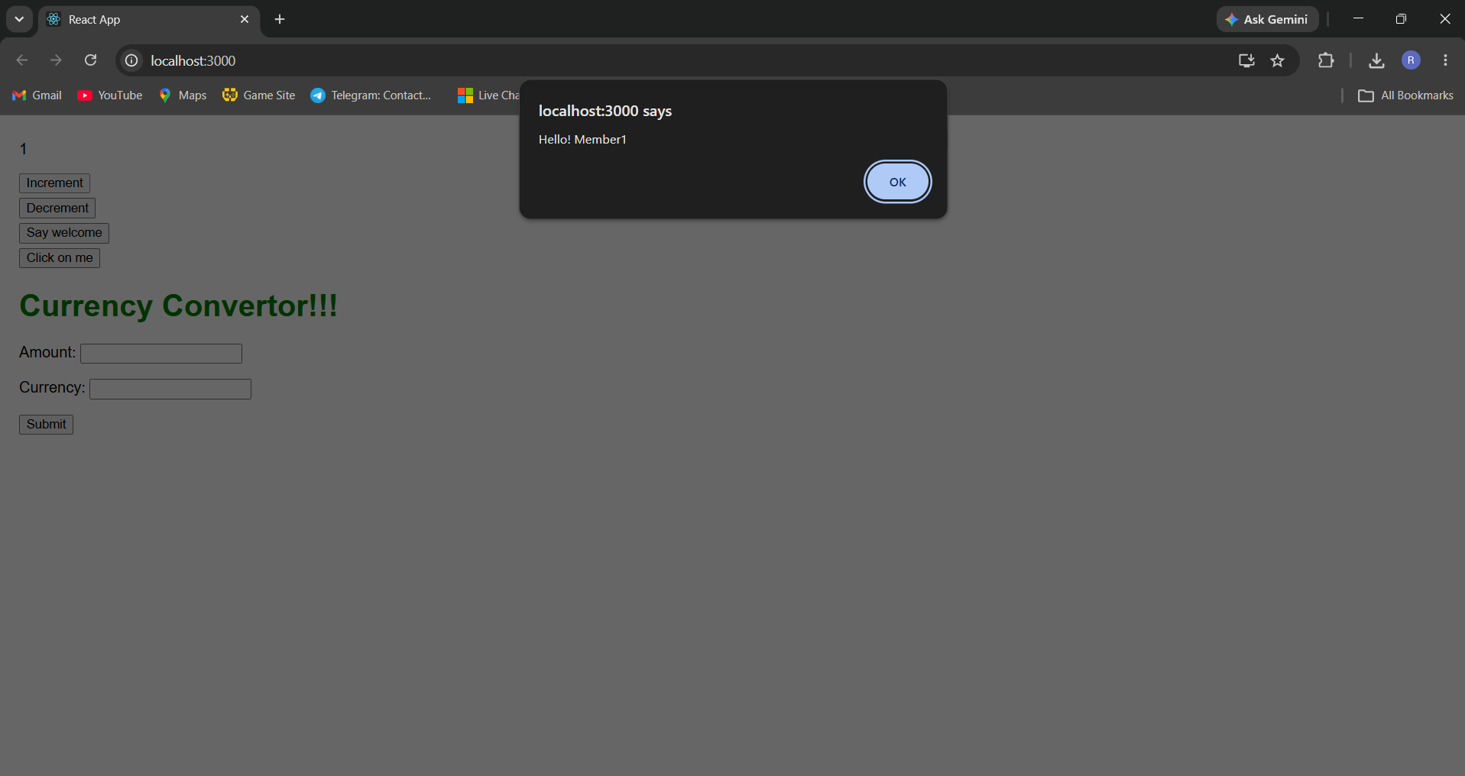
Fig 4: Counter incremented to 1 and "Hello! Member1" alert shown

3. Say Welcome Button — Passing an Argument
Clicking "Say welcome" calls the handler with the argument "welcome", and the alert box simply displays that value. This shows how a value can be passed into an event handler function rather than hardcoding it.
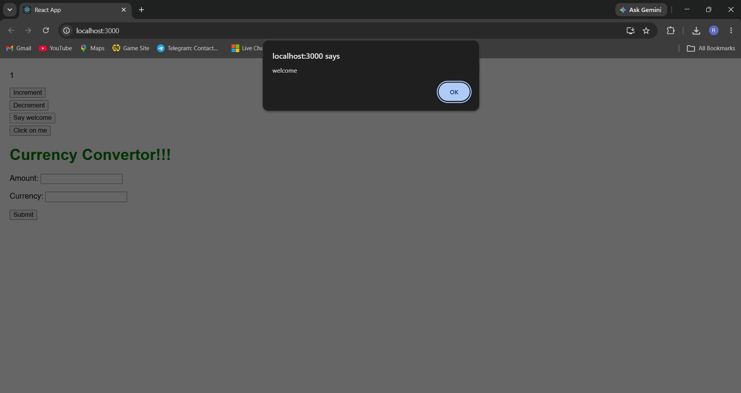
Fig 5: "Say welcome" button passing an argument to its handler

4. Click on Me Button — Synthetic Event
Clicking "Click on me" uses React's synthetic event object in the handler and shows an alert saying "I was clicked". This demonstrates how React wraps native browser events into a cross-browser SyntheticEvent.
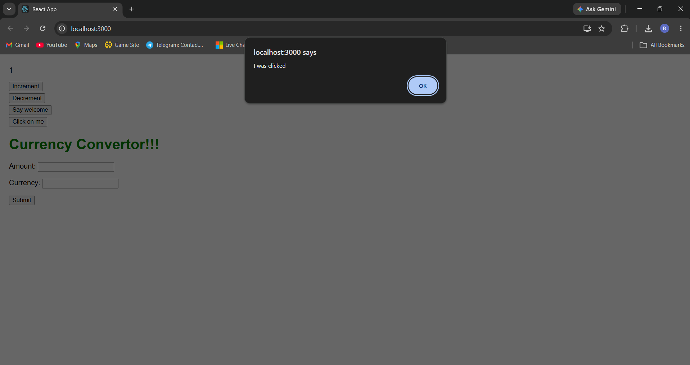
Fig 6: Synthetic event handled, showing "I was clicked"

5. Currency Convertor — Form Submit Event
Entering an Amount (100) and Currency (Euro) and clicking Submit triggers the handleSubmit function. It reads both field values from state, multiplies the amount by the conversion rate, and displays the result in an alert: "Converting to Euro Amount is 8000".
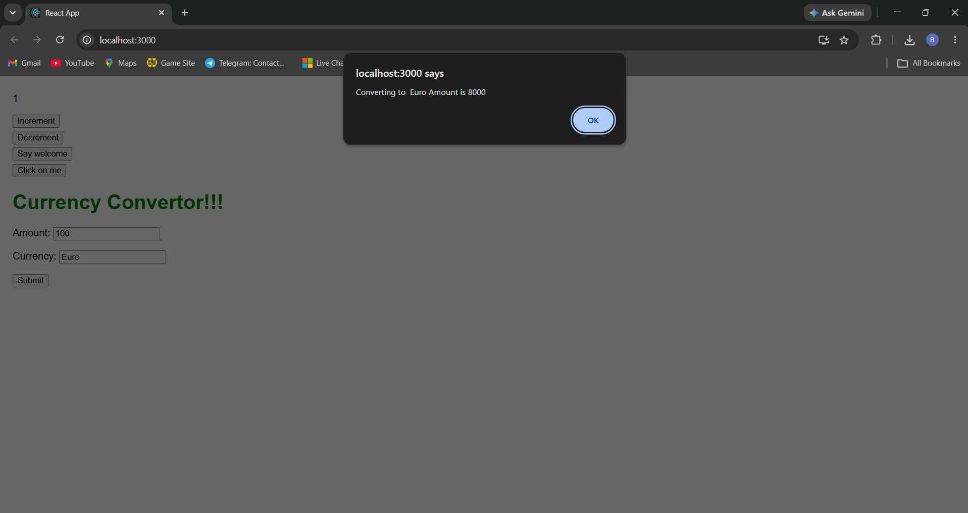
Fig 7: Currency conversion result shown after clicking Submit

Conclusion
This lab gave me hands-on practice with React event handling — binding the "this" keyword correctly inside class components, calling multiple methods from a single event handler, passing custom arguments to handlers, working with synthetic events, and handling form submission to perform a calculation. All four interactions (Increment, Say welcome, Click on me, and Currency Convertor) worked exactly as expected, matching the required output.

